Chapter 9-[Graphs](https://mfleck.cs.illinois.edu/building-blocks/version-1.3/graphs.pdf)

Sunday, January 1, 2023

7:34 PM

***Graphs:***

A ***Graph*** is denoted as (V,E), where V and E are sets representing the nodes and edges, respectively.

Two nodes connected by an edge are called ***neighbors*** or ***adjacent***.

A graph edge can be ***undirected*** (can be traversed in both directions), or ***directed*** (like relations graphs).

Two nodes can be connected by ***multiple edges***.

A node can also form a ***loop edge*** (starting and ending at itself)

A ***Simple Graph*** has *neither* multiple edges or loop edges.

***Degree*** of a node is the number of edges which a node is an endpoint for.

Handshaking Theorem:

The sum of the degrees of all the nodes is **twice** the number of edges.

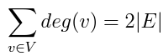

or

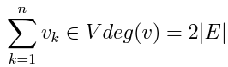

A ***Complete Graph*** on n nodes (shorthand name Kn), is a graph with n nodes in which every node is connected to every other node.



***Cycle Graph*** is a graph with edges connecting the nodes one after another and then the last node is connected to the first node. (a cycle graph contains 2n cycles, with n being the number of nodes)

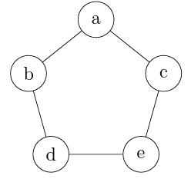

***Wheel:*** A wonkier version of a cycle graph.

The additional central "hub" node that is connected to all other nodes. So the n for a wheel has a slightly different meaning. Wn has **n+1** nodes, and **2n** edges.

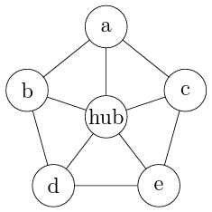

***Isomorphism:***

Given 2 graphs, G1 = (V1, E1) and G2 = (V2, E2),

An ***Isomorphism*** from G1 to G2 is a bijection



Such that a function relates all the nodes in V1 and all the nodes in V2, and two nodes in V1 *(say, nodes x and y)* are joined by an edge iff two corresponding nodes *(say, nodes f(x) and f(y))* are joined by an edge.

Graph Isomorphism is like equivalence relation, although looks different, are pretty much the same thing. (same abstract graph)

***Properties of Isomorphism:***

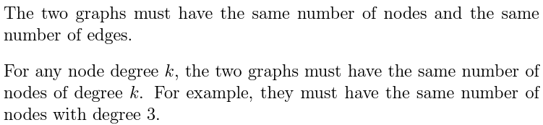

Proving Two Graphs are NOT Isomorphic can be done by using the above properties (when they are false then it is not isomorphic)

***Subgraphs:***

If G and G' are graphs, then G' is a subgraph of G if and only if the nodes of G' are a subset of the nodes of G and the edges of G' are a subset of the edges of G.

If two graphs G and F are isomorphic, then any subgraph of G must have a matching subgraph somewhere in F.

To prove that two graphs are NOT Isomorphic, try to find sub graphs in both that are not matching.

***Walk:***

Going from a specific node to another node, the finite sequence of nodes (or edges).

***Closed Walk*** is the walk with the same starting and ending node.

***Open Walk*** is the opposite.

A ***Path*** is a walk in which **no** node is used **more than once**.

A ***Cycle*** is a closed walk with at least three nodes in which no node is used more than once except the starting and ending node.

An ***Acyclic*** graph does NOT contain any cycles.

A ***Connected Graph*** has a walk between every pair of nodes.

If a graph is not connected, you might be able to divide it into ***Connected Components***, with each component containing the max amount of nodes.

A ***Cut Edge*** is a singular edge that would make a graph no longer connected **if removed**.

***Distance:*** distance, yea…

***Diameter*** of a graph: the maximum distance between any pair of nodes in the graph.

***Euler Circuit*** of a graph is a closed walk that uses **each edge** of the graph exactly once. (Every single edge needs to be used exactly once)

*An Euler circuit is possible exactly when the graph is* ***connected*** *and each node has an* **even *degree****.*

A graph G = (V,E) is a ***Bipartite Graph*** if we can split V into two non-overlapping subsets V1 and V2 such that every edge in G connects an element of V1 with an element of V2.

*(we can divide the set of nodes in a way that no edge connects two nodes from the same part of the division)*

For example, here's a Bipartite Graph split into groups R and G:

